CSE 2221: system programming

Installation of Linux Ubuntu 11.10

Linux:
We will learn the installation procedure of Ubuntu 11.10.

Installation steps:
Step1:
First of all download the Ubuntu 11.10 from the link http://www.ubuntu.com/download/ubuntu/download

Step 2:
Using your disc burning software, burn the .iso you downloaded to a CD.

Step 3:
Before you go any further, ensure all important data is backed up in case of data loss on your drives. This guide assumes you have media backups of your Windows partitioned hard drive and you are safe to proceed.

Step 4:
Ensure you have a network cable connected, restart your computer, and boot from the CD drive. In our lab we will not install it while connecting to the internet.
Step 5:
The LiveCD will load up, and you'll be presented by the following box:
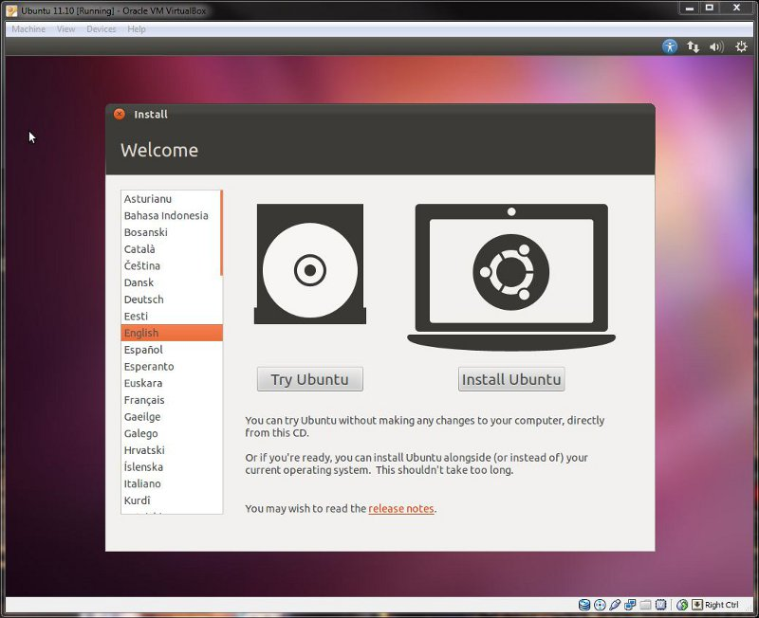

Step 6:
By clicking the install button You'll be greeted by the "Preparing to install Ubuntu" screen, exactly as below:
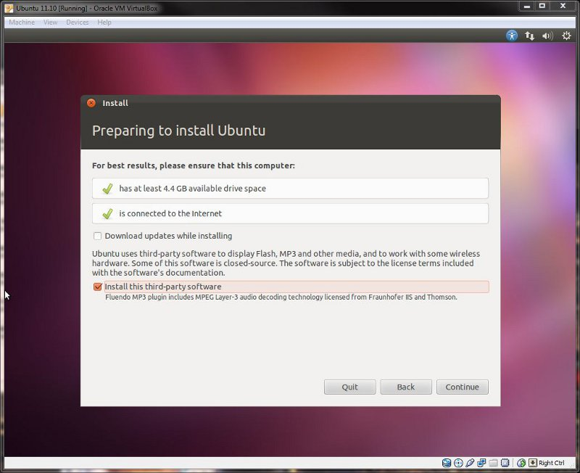

Step 7:
The next screen you will see is "installation type," what you see will be dependent on whether you have an existing Windows installation or not.

Step 7-A:
Those of you that have current Windows installations or are going to dual-boot with another existing OS will be presented with a screen similar to below

You have three options available:
1. You can choose the first option and install Ubuntu alongside your existing OS.
2. You can opt to replace your Windows installation with Ubuntu, allowing the installer to format your current partitions and automatically create new ones for Linux.
3. You can choose "something else" and create your own partition scheme and sizing

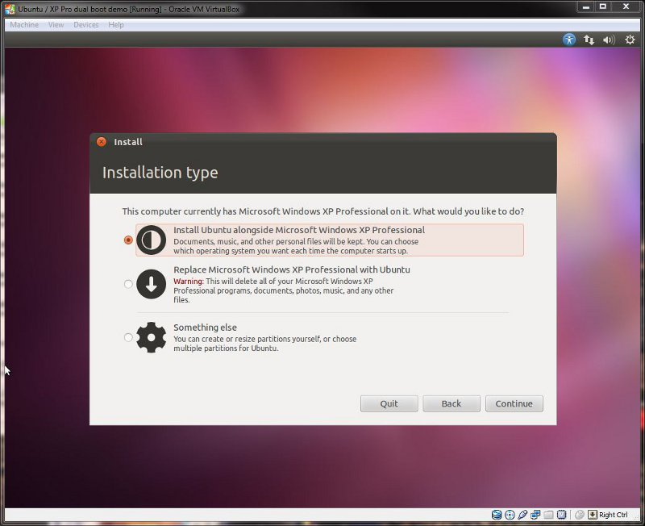

Step 7-B:
Having selected the "something else" option you will be presented with the following window:
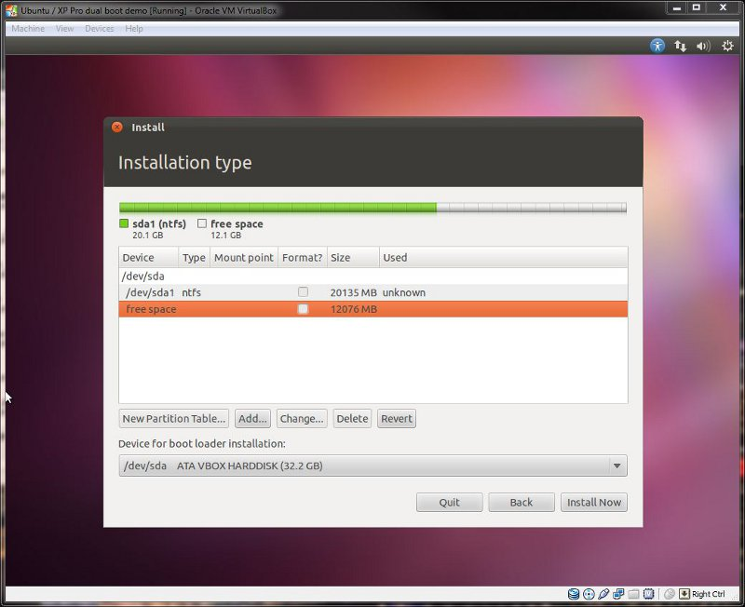

Once you have done that, you should be looking at something like below.
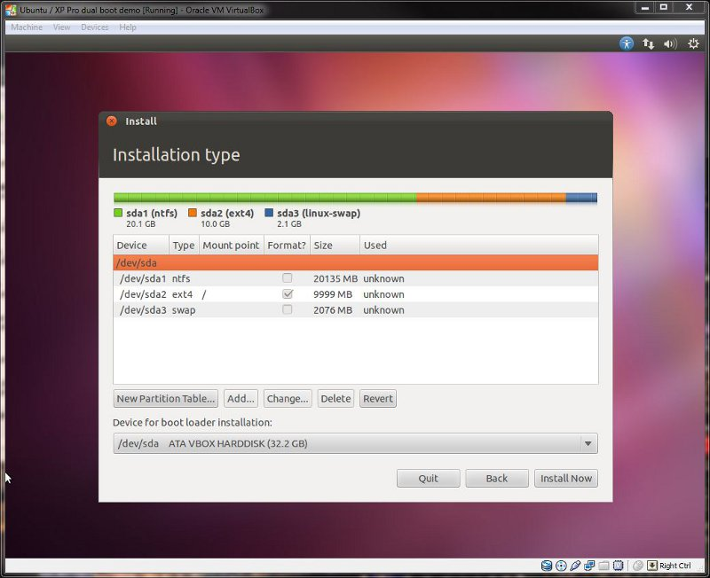

Step 8:
The next screen to appear will be keyboard layout:
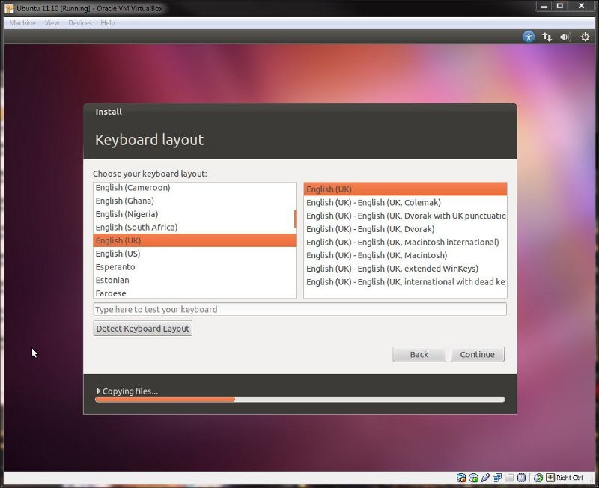
Step 10:
You will now be greeted by the "who are you" screen, ready for you to fill out with your user details:
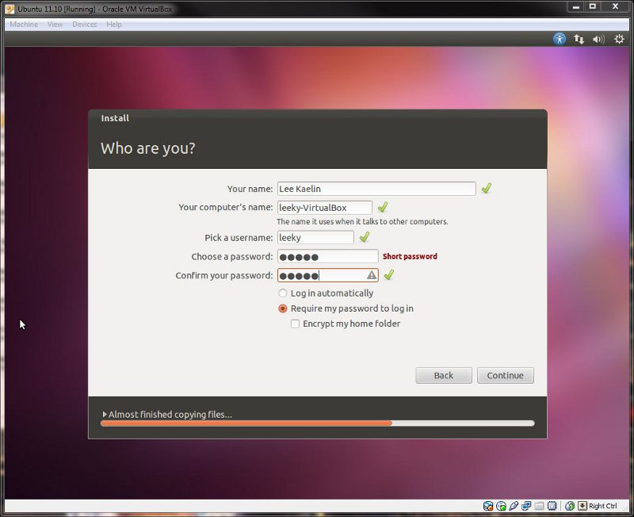

Step 10:
The installation information screens will now appear as Ubuntu continues the installation:
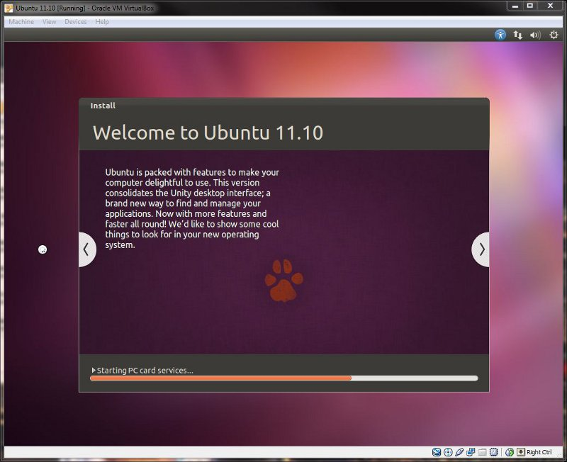

step 11:
Once installation has finished, you will be presented with the following box:
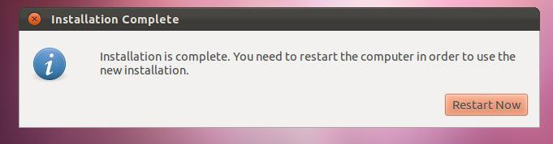

Step 12:
For those of you that have Ubuntu as the only OS the computer will boot directly into Linux. If you're dual-booting, you will see the GRUB menu appear similar to below:
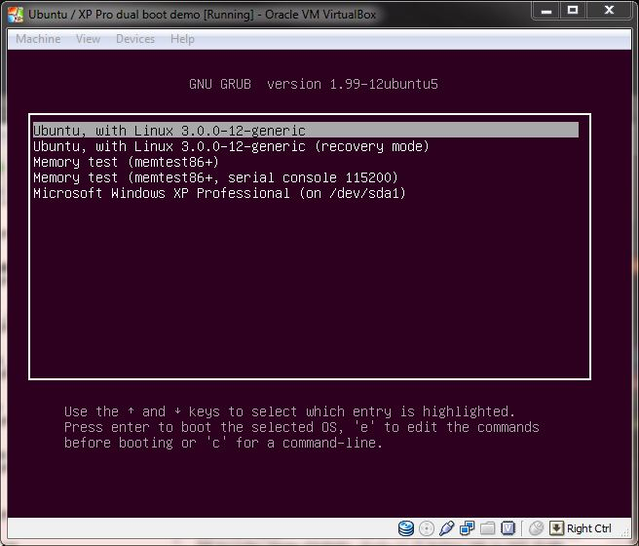

Step 13:
For those that elected to automatically log into Ubuntu, you will go straight to the desktop in Step 15. For everyone else, you will be greeted with the new login manager for Ubuntu:
